DevOps Project:

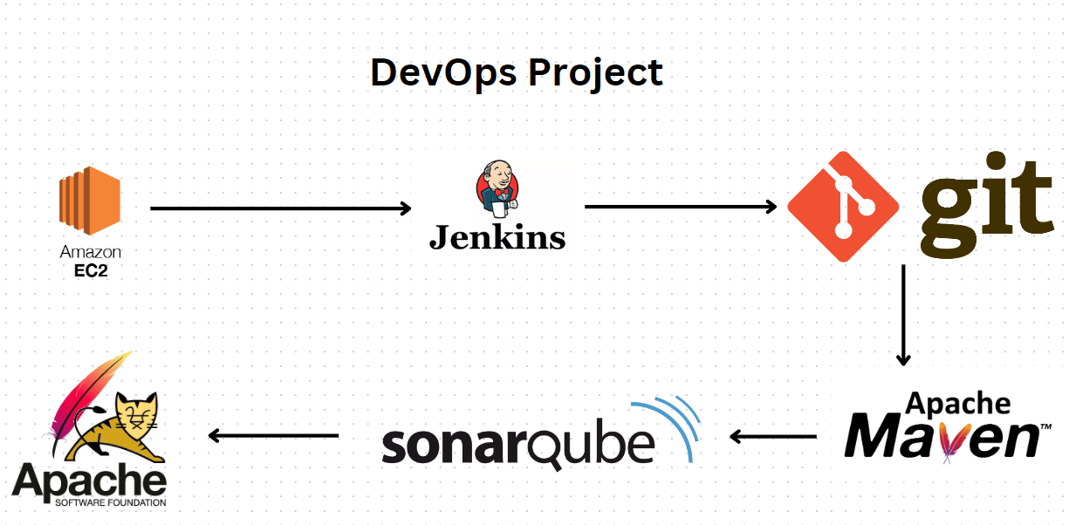

Step 1: Launch EC2 instance for Jenkins using t2.micro.

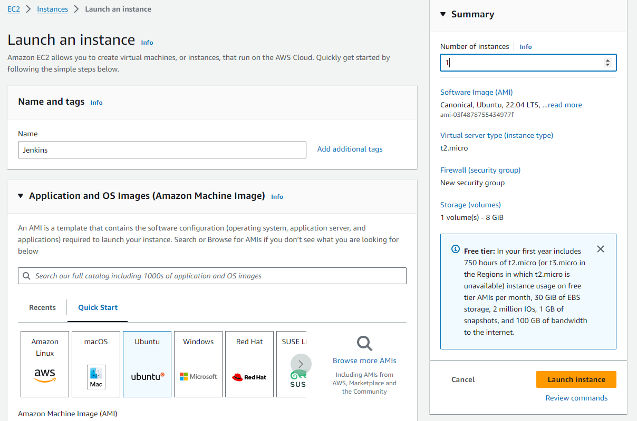

Step 2: Connect EC2 using SSH.

Step 3: Run Command to update a system: **sudo apt update**

Step 4: Install JDK:

Cmd: **sudo apt install openjdk-11-jre-headless -y**

Step 4: Download and Install Jenkins

**sudo wget -O /usr/share/keyrings/jenkins-keyring.asc \**

**https://pkg.jenkins.io/debian-stable/jenkins.io-2023.key**

**echo deb [signed-by=/usr/share/keyrings/jenkins-keyring.asc] \**

**https://pkg.jenkins.io/debian-stable binary/ | sudo tee \**

**/etc/apt/sources.list.d/jenkins.list > /dev/null**

**sudo apt-get update**

**sudo apt-get install Jenkins -y**

Step 5: Start Jenkins service.

Cmd: **sudo systemctl start Jenkins   
 sudo systemctl enable Jenkins**

To check Jenkins service status

Cmd: **sudo systemctl status Jenkins**

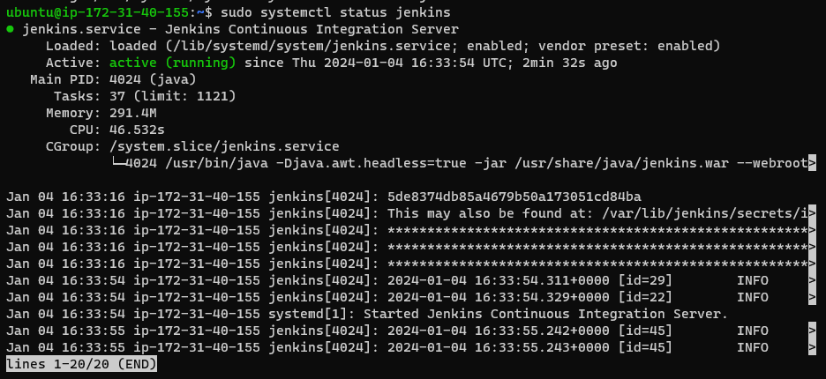

Step 5: Now add port no 8080 in a security group.

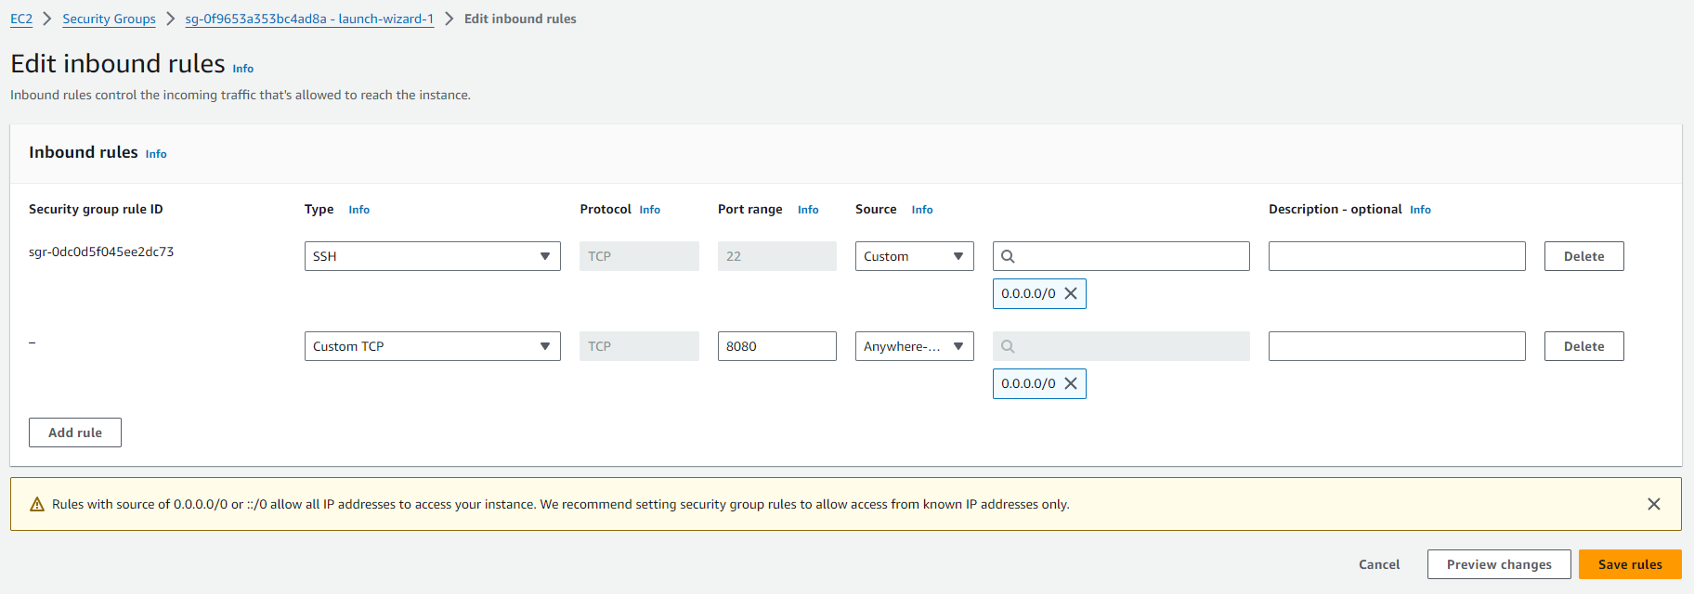

Step 6: To access Jenkins.

Copy instance public IP and then add listener 8080 to access Jenkins.

[**http://InstancePublicIP:8080/**](http://InstancePublicIP:8080/)

To unlock Jenkins take password from

sudo cat /var/lib/jenkins/secrets/initialAdminPassword and paste.



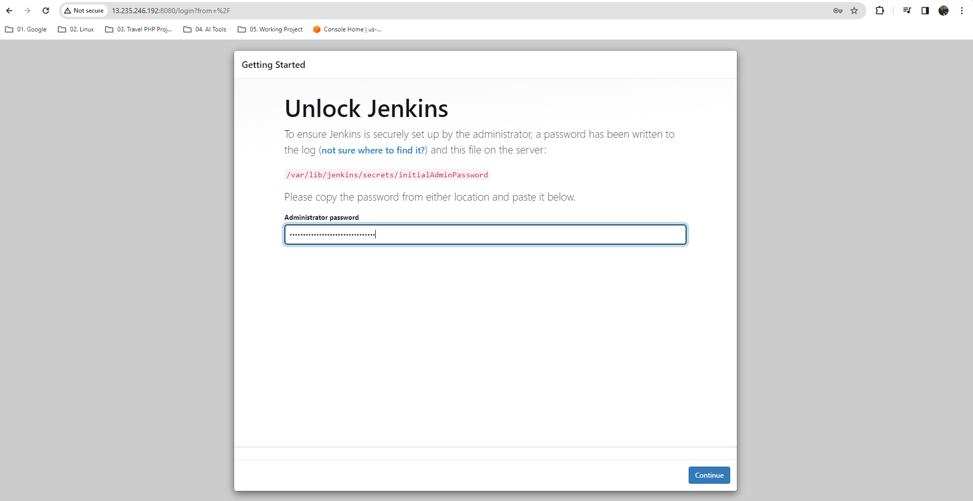

Install suggested plugins.

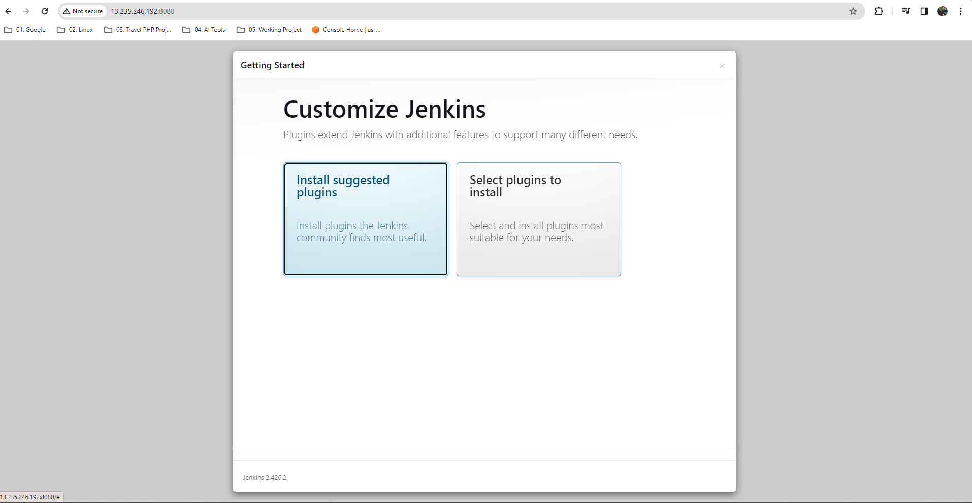

Click save and finish.

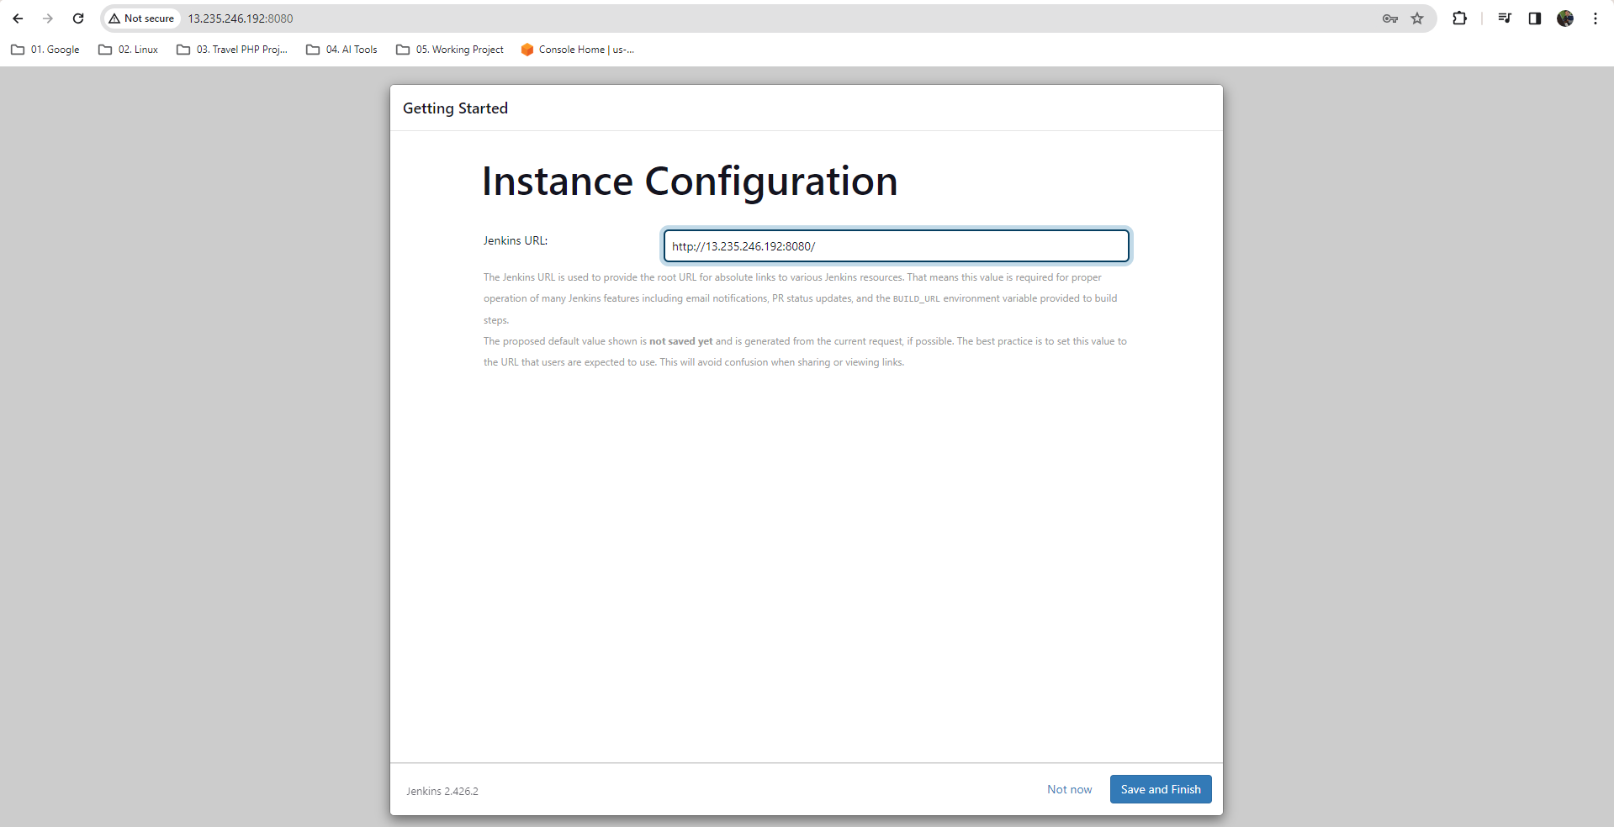

Step 6: Create first admin user in Jenkins then save and continue and start using Jenkins.

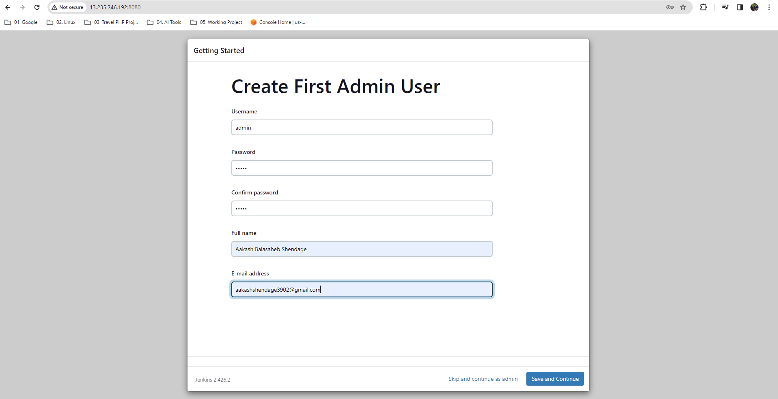

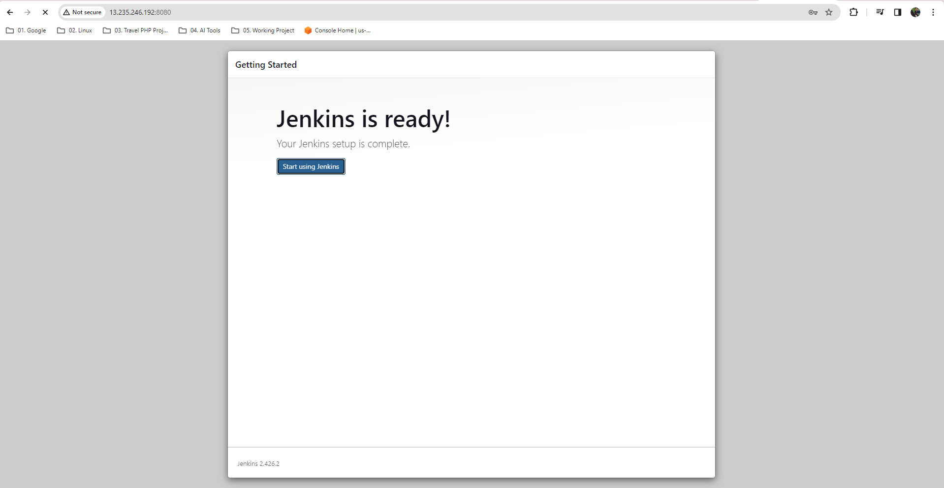

Step 6: Now create a job.

